Glossary:
Term | Definition
Polymorphism | The ability of different objects to use the same method name but perform different actions.
Encapsulation | Keeping data inside a class and controlling how that data can be accessed or changed.
Abstraction | Hiding complex implementation details and exposing only the functionality needed by the user.
Nested Function | A function defined inside another function, where the inner function can access values from its outer function.
Merge Conflict | A situation in Git where changes from different branches cannot be automatically combined and require manual resolution.

Technical Learning Report: Week 5 Day 1
Date: September 30, 2026
Intern Name: Shekhar Singh Rawal
Subject: Python OOP for Test Automation and Git Branching & Collaboration

1. Objective
The objective of Day 1 was to develop an understanding of Python Object-Oriented Programming concepts relevant to test automation and to learn how Git branching and merging support team-based development. The learning focused on variables and scope, classes and objects, inheritance, polymorphism, encapsulation, abstraction, exception handling, and function execution flow in Python. Git collaboration topics included branches, merging, and conflict handling. The overall objective was to understand how OOP can support reusable and maintainable automation code and how Git branches help teams work on shared code without directly modifying the same branch.

2. Technical Breakdown

2.1 Python Variables and Scope
Variables store values that can be used by a program. Python variables can exist at different scopes depending on where they are declared.

2.1.1 Global Variable
A global variable is declared outside a function and can be accessed from different parts of the program.

2.1.2 Local Variable
A local variable is created inside a function and is normally available only within that function.
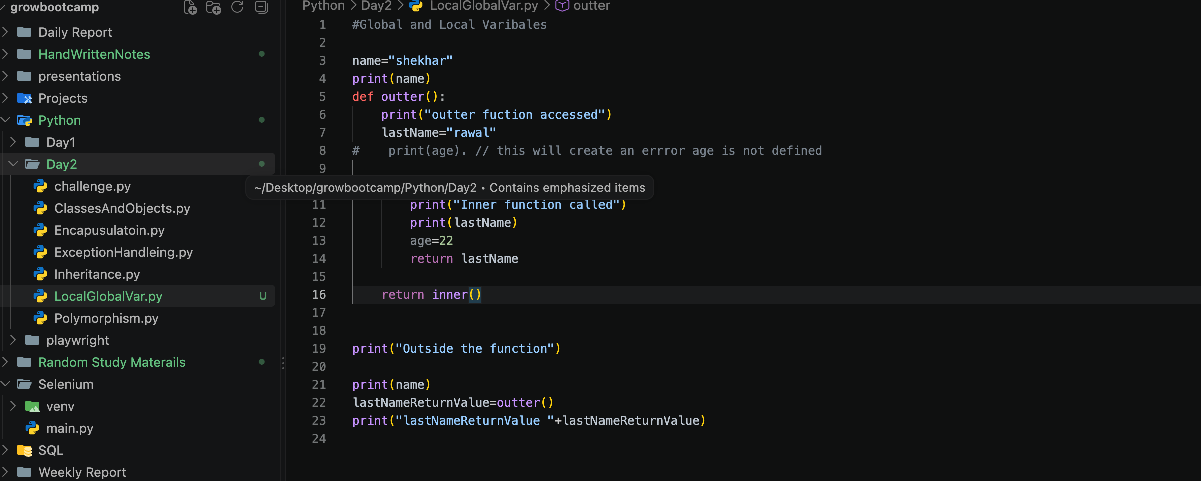

2.2 Classes, Constructors and Objects
A class is a blueprint used to create objects. An object is an actual instance created from a class.
A constructor is a special method that runs when an object is created and prepares the object.
Type | Simple Definition
__init__() | Initializes the object by giving it its starting data.
__new__() | Creates the object before __init__() runs.

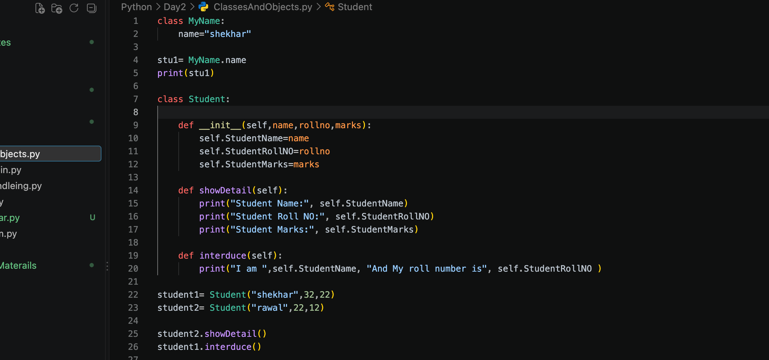

3. OOP Concepts Practiced

3.1 Inheritance
Inheritance allows a child class to reuse functionality from a parent class.
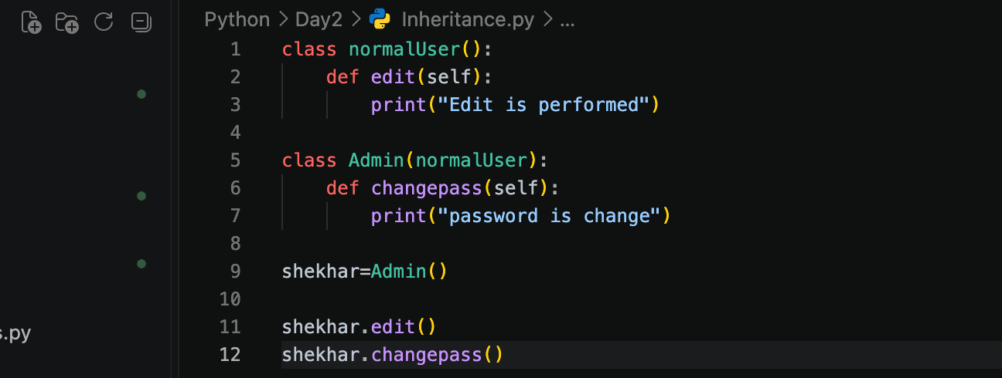

QA Example
A test automation framework may have a common BasePage containing common browser actions, while individual page classes inherit those actions.

3.2 Polymorphism
Polymorphism means that different objects can provide the same method name while performing different implementations.
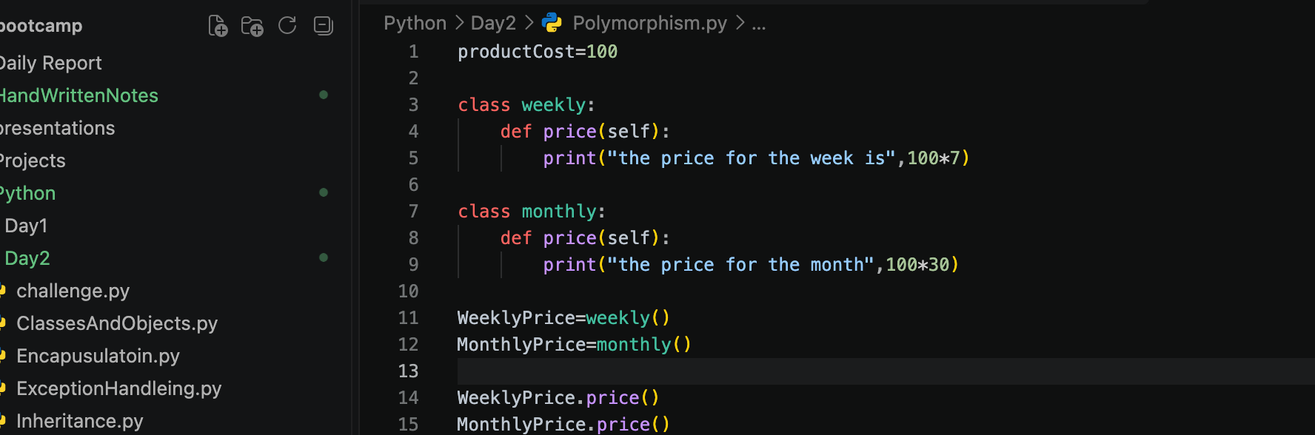

3.3 Encapsulation
Encapsulation controls how data is accessed within a class.
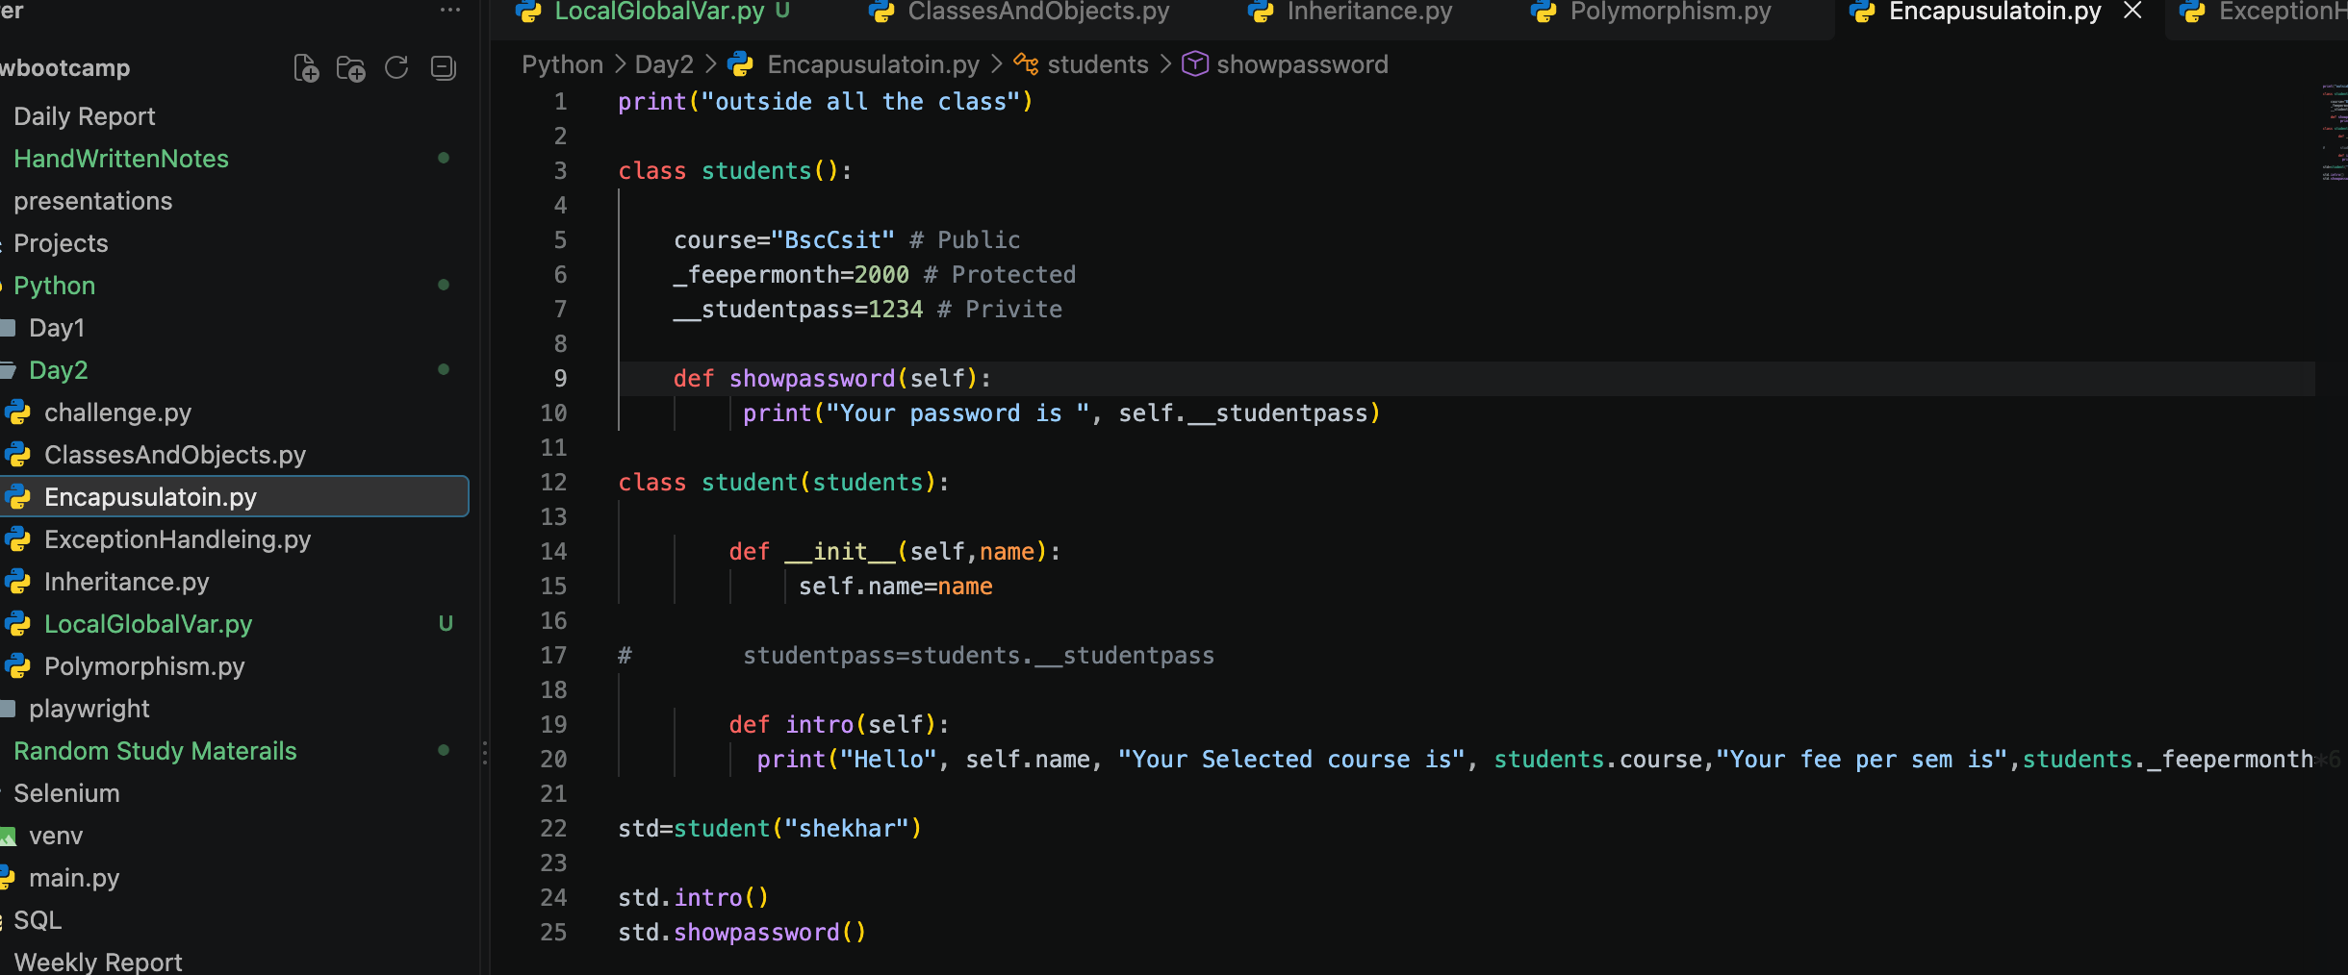

Access Levels Practiced
Type | Example | Purpose
Public | course | Can be accessed normally
Protected | _feepermonth | Intended for internal/subclass use
Private | __studentpass | Intended to restrict direct access

QA Relevance
Encapsulation can help keep test data, page elements, configuration values, and internal implementation details organized within automation classes.

3.4 Data Abstraction
Abstraction focuses on exposing the required functionality while hiding unnecessary implementation details.

4. Exception Handling
Exception handling was practiced using try, except, else, and finally.
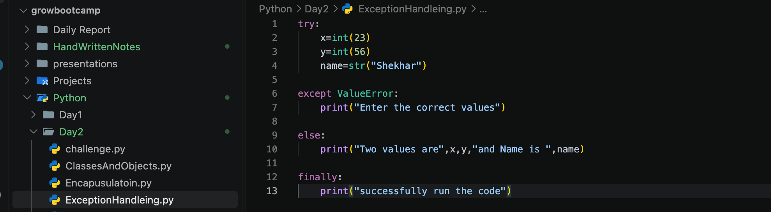

Purpose of Each Block
Block | Purpose
try | Contains code that may produce an exception
except | Handles the exception
else | Runs when no exception occurs
finally | Runs regardless of whether an exception occurs

QA Relevance
Exception handling is important in automation because an unexpected condition should be handled clearly rather than causing the entire automation framework to fail without useful information.

5. Nested Functions
A nested function example was also practiced:
def outer():
print("2")
def inner():
print("3")
return "X"
print("4")
return inner
func = outer()
value = func()
The expected execution order practiced was:
1 → 5 → 2 → 4 → 6 → 3 → 7 → X

6. Git Branching, Merging and Conflict Handling
The Git portion of the day's learning focused on why teams use branches rather than having every developer directly modify the same branch.

6.1 Why Use Git Branches?
A branch provides an isolated line of development.

Team Example
Developer | Branch | Work
Developer A | feature-login | Login automation
Developer B | feature-search | Search automation
Developer C | bugfix-header | Header bug fix
After the work is reviewed and accepted, the changes can be merged into the shared branch.

6.2 Git Branch Commands
The relevant Git concepts covered were:

git branch
git checkout <branch>
6.3 Git Merge
Git merge combines changes from one branch into another.
For example:
main
|
+--- feature-A
|
+--- feature-B
After development, the feature branches can be merged into the target branch.
The day's practice included Git merge and conflict handling as part of the Git learning.

6.4 Merge Conflict
A merge conflict can occur when two branches modify the same part of a file in incompatible ways.
Example:
Branch A:
name = "Shekhar"
Branch B:
name = "Rawal"

7. AI-Assisted Learning
AI tools such as ChatGPT and Claude were used as learning assistants to understand OOP, Playwright, and Git concepts.

1. Playwright and OOP
Prompt used:
“Refactor this Playwright test code using OOP and Page Object Model pattern.”
For example, a login action such as:
page.fill("#username", "shekhar")
page.fill("#password", "1234")
page.click("#login")
was refactored into a LoginPage class with a reusable login() method. This helped demonstrate how classes, objects, methods, and encapsulation can make automation code more reusable and maintainable.

2. Git Branching and Pull Requests
Prompt used:
“Explain Git branching and Pull Requests with a simple team example.”
AI explained a workflow such as:
Create Branch → Write Code → Commit → Push → Pull Request → Review → Merge
For example, a developer could create a feature-login branch to work on login automation without directly changing the main branch.
AI was used mainly to understand concepts, simplify explanations, and review code, rather than blindly copying generated solutions.

8. Key Findings & Best Practices
- Classes help organize reusable automation functionality.
- Objects allow the same class structure to be used with different data.
- Inheritance can reduce repeated code by allowing child classes to reuse parent functionality.
- Polymorphism allows similar method names to provide different behavior.
- Encapsulation helps keep data and implementation details organized.
- Exception handling provides a structured way to handle unexpected situations.
- Nested functions helped demonstrate function scope and execution flow.
- Git branches allow team members to work independently without directly changing the shared branch.
- Merge conflicts require reviewing and resolving competing changes before the final code is committed.
- Pull Requests provide a structured point for code review before merging changes.
- For test automation, OOP concepts can be used to build reusable Page Object and utility structures.

9. Conclusion
Day 1 of Week 5 focused on strengthening Python programming concepts required for automation development and introducing collaborative Git workflows. Practical exercises covered variables and scope, classes, objects, constructors, inheritance, polymorphism, encapsulation, abstraction, exception handling, and nested function execution. Git learning covered branching, merging, and conflict handling. These concepts provide the foundation for developing reusable and maintainable automation code and for collaborating safely on shared test automation projects.

